# Exercises: Web API - Introduction

Problems for exercises and homework for the [“Java MVC Frameworks - Spring” course @ SoftUni](https://softuni.bg/trainings/1538/java-mvc-frameworks-spring-march-2017). You are given a skeleton for the exercise. You will also receive DB with sample data.

## Watching Trailers

Get familiar with the **home/index** view. Check out the elements with id "**trailer**" and "**title**". Finally, take a look at the button with class "**btn-trailer**". Open the scripts/home.js file. It contains a function trailer() that you need to implement. The function should make an AJAX GET request to a REST action in the GameController, that will return the GameInfoView model as **JSON**. With that JSON it should fill the #trailer and #title html elements. After doing it, click on the "**Trailer**" button on the home page. You should see a modal with the game trailer:

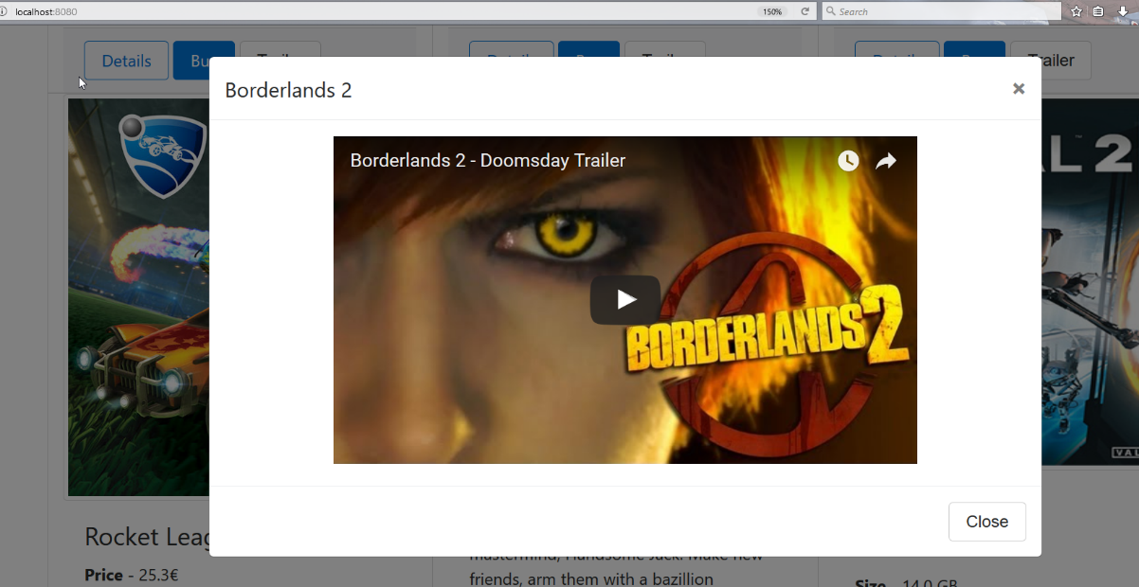

## Buying Games

In the same JS file, you need to implement the buy() function. Create a new **REST** controller which will deal with the user cart. The buy() function must send an AJAX **POST** request to an action. You must keep a collection of **unique** **games** that the user wants to buy. You might need to find a way to send **CSRF** token with your request.

## Viewing Cart

Take a look at the fragments/header file and locate the #cart-items element. Inside, you will need to add all of the game **titles** that the user wants to buy. This means that every time the dropdown is clicked, you will need to send **GET** request with **AJAX** to retrieve them. Luckily for you the dropdown is already linked with the getCart() function in the scripts/header.js file. You must implement it. For each game title, create new <p> element and add the "dropdown-item" class to it. Finally, append it to the #cart-items element. You can see picture in the next task.

## Clearing the Cart

If there are any games added to the cart, there should be a button to **delete all items**. Make **AJAX** request that will **clear the collection**. Additionally, if there are no items in the collection, the cart must show "**Empty Cart**" element:

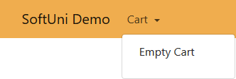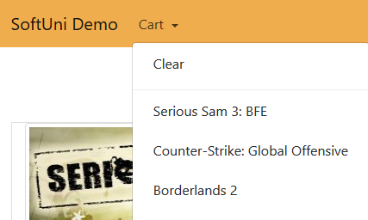

## Install Android SDK

This task is a preparation for your next lecture. You will need **Android SDK** and either **Android Studio** or **Android plugins** for **IntelliJ Idea**.